In this video, we will discuss **implementing paging using Skip and Take**operators in LINQ.   
  
   
  
We will use the following Student class in this demo. Notice that, there are **11 total Students**. We want to display a maximum of **3 students per page**. So there will be **4 total pages.**The last page, i.e **Page 4**will display the last **2 students**.

public class Student

{

    public int StudentID { get; set; }

    public string Name { get; set; }

    public int TotalMarks { get; set; }

    public static List<Student> GetAllStudetns()

    {

        List<Student> listStudents = new List<Student>

        {

            new Student { StudentID= 101, Name = "Tom", TotalMarks = 800 },

            new Student { StudentID= 102, Name = "Mary", TotalMarks = 900 },

            new Student { StudentID= 103, Name = "Pam", TotalMarks = 800 },

            new Student { StudentID= 104, Name = "John", TotalMarks = 800 },

            new Student { StudentID= 105, Name = "John", TotalMarks = 800 },

            new Student { StudentID= 106, Name = "Brian", TotalMarks = 700 },

            new Student { StudentID= 107, Name = "Jade", TotalMarks = 750 },

            new Student { StudentID= 108, Name = "Ron", TotalMarks = 850 },

            new Student { StudentID= 109, Name = "Rob", TotalMarks = 950 },

            new Student { StudentID= 110, Name = "Alex", TotalMarks = 750 },

            new Student { StudentID= 111, Name = "Susan", TotalMarks = 860 },

        };

        return listStudents;

    }

}

**Here is what we want to do**  
**1.** The program should prompt the user to enter a page number. The Page number must be between 1 and 4.  
**2.** If the user does not enter a valid page number, the program should prompt the user to enter a valid page number.  
**3.** Once a valid page number is entered, the program should display the correct set of Students  
  
For example, **the output of the program**should be as shown below.  
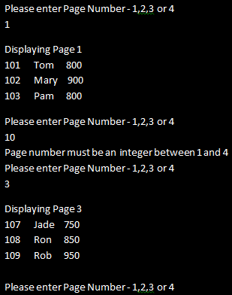   
  
The following console application use **Skip()** and **Take()**operators to achieve this.

using System;

using System.Collections.Generic;

using System.Linq;

namespace Demo

{

    class Program

    {

        public static void Main()

        {

            IEnumerable<Student> students = Student.GetAllStudetns();

            do

            {

                Console.WriteLine("Please enter Page Number - 1,2,3 or 4");

                int pageNumber = 0;

                if (int.TryParse(Console.ReadLine(), out pageNumber))

                {

                    if (pageNumber >= 1 && pageNumber <= 4)

                    {

                        int pageSize = 3;

                        IEnumerable<Student> result = students

                                                     .Skip((pageNumber - 1) * pageSize).Take(pageSize);

                        Console.WriteLine();

                        Console.WriteLine("Displaying Page " + pageNumber);

                        foreach (Student student in result)

                        {

                            Console.WriteLine(student.StudentID + "\t" +

                                                                        student.Name + "\t" + student.TotalMarks);

                        }

                        Console.WriteLine();

                    }

                    else

                    {

                        Console.WriteLine("Page number must be an integer between 1 and 4");

                    }

                }

                else

                {

                    Console.WriteLine("Page number must be an integer between 1 and 4");

                }

            } while (1 == 1);

        }

    }

}

**Please Note:** The condition in the while loop puts the program in an infinite loop. To end the program, simply close the console window.